|  |  |
| --- | --- |
| **Logo_FPT_University_doc** | **MINISTRY OF EDUCATION AND TRAINING** |

|  |
| --- |
| **FPT UNIVERSITY** |
| Capstone Project Document |
| Drop It |
|  |
| |  |  | | --- | --- | | **Group 08** | | | **Group Members** | Lê Khôi Phong  Đào Như Tùng  Công Minh Hiếu  Nguyễn Thanh Tùng  Đặng Quốc Duy | | **Supervisor** | Lâm Hữu Khánh Phương | |
|  |

- Ho Chi Minh City, 08/2013 –

**Record of Changes**

|  |  |  |  |  |
| --- | --- | --- | --- | --- |
| **Date** | **Changed Item** | **Description** | **By** | **Version** |
| Aug-1-2013 | All | Create the document | TungNT | 0.1 |
|  |  |  |  |  |
|  |  |  |  |  |

Table of Contents

[6.1. Installation Guide 5](#_Toc364389962)

[**6.1.1.** **Setting up the environment at server side** 5](#_Toc364389963)

[**6.1.2.** **Deployment at server side** 5](#_Toc364389964)

[6.2.1.1. Manage User 6](#_Toc364389965)

[6.2.1.1.1 Active/Deactive User 6](#_Toc364389966)

[6.2.1.1.2 Allow user selling/ Disallow user selling 6](#_Toc364389967)

[6.2.1.2. Manage Ticket 7](#_Toc364389968)

[6.2.1.2.1 Update Ticket 7](#_Toc364389969)

[6.2.1.2.2 Delete Ticket 8](#_Toc364389970)

[6.2.1.2.3 Apprive\Disapprove Ticket 8](#_Toc364389971)

[6.2.1.3. Manage Event 8](#_Toc364389972)

[6.2.1.3.1 Create Event 8](#_Toc364389973)

[6.2.1.7. Update Event 9](#_Toc364389974)

[6.2.1.8. Delete Event 10](#_Toc364389975)

[6.2.1.9. Approve/Disapprove Event 10](#_Toc364389976)

[6.2.1.10. Create Venue 11](#_Toc364389977)

[6.2.1.11. Update Venue 12](#_Toc364389978)

[6.2.1.12. Approve/Disapprove Venue 12](#_Toc364389979)

[6.2.1.13. Create Category 13](#_Toc364389980)

[6.2.1.14. Update Category 14](#_Toc364389981)

[6.2.1.15. Show/Hide Category 14](#_Toc364389982)

[6.2.1.16. Close Request 15](#_Toc364389983)

[6.2.1.17. Update Transaction 17](#_Toc364389984)

[6.2.1.18. Create Setting 19](#_Toc364389985)

[6.2.1.19. Update Setting 20](#_Toc364389986)

[6.2.1.20. Delete Setting 20](#_Toc364389987)

[**6.2.1.** **User’s Guide** 21](#_Toc364389988)

[6.2.2.1. View Website basically 21](#_Toc364389989)

[6.2.2.2. Register 23](#_Toc364389990)

[6.2.2.3. Login 23](#_Toc364389991)

[6.2.2.4. Buy Ticket 24](#_Toc364389992)

[6.2.2.5. Post Ticket 26](#_Toc364389993)

[6.2.2.6. Update Posted Ticket 27](#_Toc364389994)

[6.2.2.7. Delete Posted Ticket 28](#_Toc364389995)

[6.2.2.8. Request Ticket 28](#_Toc364389996)

[6.2.2.9. Respond Ticket 29](#_Toc364389997)

[6.2.2.10. Close Ticket Request 30](#_Toc364389998)

[6.2.2.11. View Buy History 30](#_Toc364389999)

[6.2.2.12. View Sell History 30](#_Toc364390000)

[6.2.2.13. Follow/Unfollow Buy Event 31](#_Toc364390001)

[6.2.2.14. View Follow List 32](#_Toc364390002)

[6.2.2.15. View Notification List 32](#_Toc364390003)

[6.2.2.16. Change Password 32](#_Toc364390004)

[6.2.2.17. Change Personal Information 33](#_Toc364390005)

[6.2.2.18. Search Event 34](#_Toc364390006)

[6.2.2.19. Logout 35](#_Toc364390007)

# Installation Guide

## **Setting up the environment at server side**

The following software must be installed into the server machine:

#### **Hardware requirements:**

* Personal computers for developing with the minimum configuration: CPU Core 2 Duo 2.0GHz, 4GB of RAM, 120GB of hard disk, and internet.

#### **Software requirements**:

* + Operating system: Windows 7, Windows Server 2008 R2 or higher
  + Web Server: IIS 7.5 or higher
  + Microsoft SQL Server 2012 or higher: used to create and manage the database for web application

## **Deployment at server side**

Publish Database project **DropItDBModel** User‘s Guide

Notes: The number after description text points to the area in figure that describe next to the number (e.g. “Click on button (1-6.2.1.1)” points to the area 1 of the figure 6.2.1.1).

**Admin’s Guide**

### Manage User

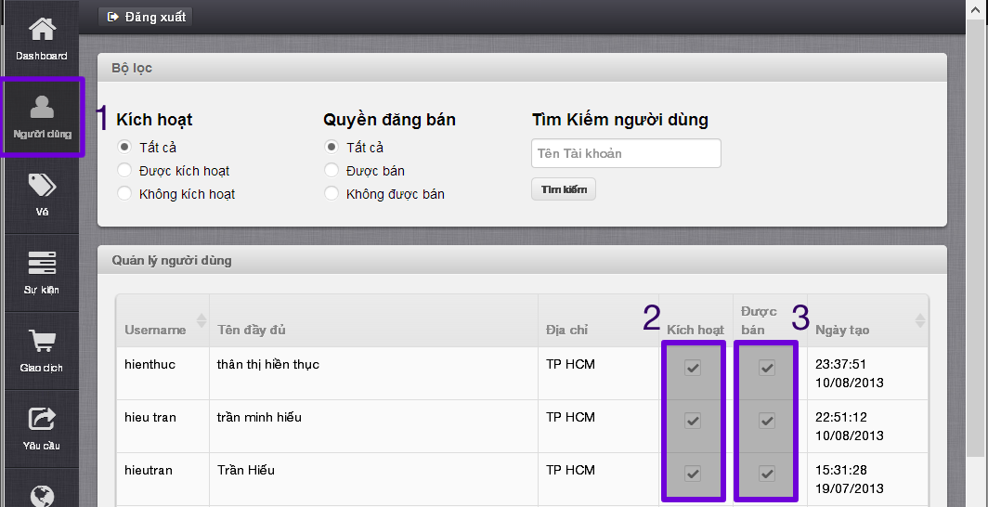

**Figure 6.2.1.1 Manage user UI**

Click on “Người dùng” tab (1-6.1.1.1) to enter Manage User page

### Active/Deactive User

-Choose deactive user and check “Kích hoạt” box (2-6.2.1.1) to active

-Choose active user and uncheck “Kích hoạt” box (2-6.2.1.1) to deactive

* Message active/deactive successful displays on top

### Allow user selling/ Disallow user selling

* Choose unsalable user and check “Được bán” box (3-6.2.1.1) to allow selling
* Choose salable user and uncheck “Được bán” box (3-6.2.1.1) to not allow selling
* Message salable/unsalable successful displays on top

### Manage Ticket

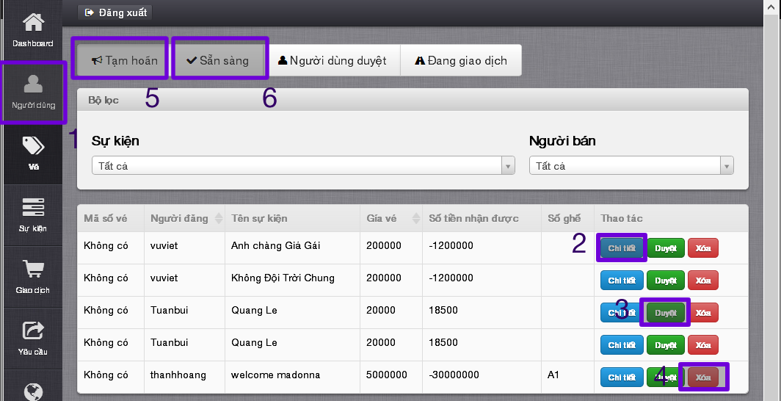

**Figure 6.2.1.2 Manage ticket UI**

* Click on “Vé” tab to enter Manage Ticket page

### Update Ticket

* Click on “Chi tiết” button (2-6.2.1.2) to view ticket details and update ticket

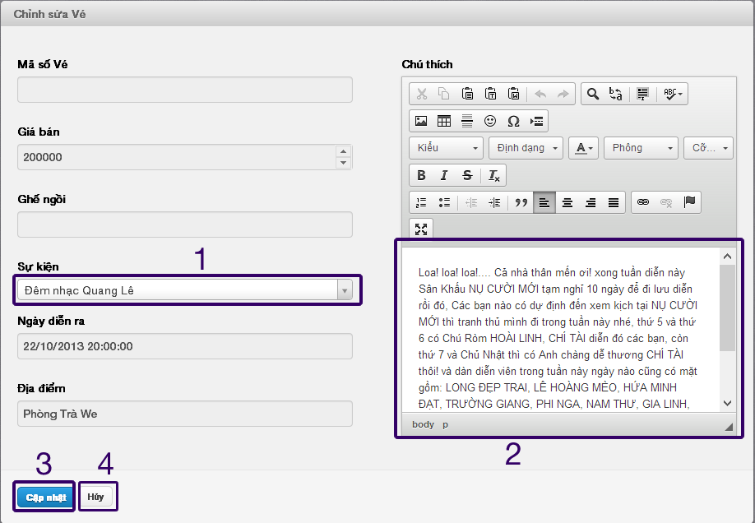

**Figure 6.2.1.2.1 Detail\Edit ticket UI**

* In edit ticket page, only field “Sự kiện” (1-6.2.1.2.1) and “Chú thích” (2-6.2.1.2.1) can be edited.
* After edited, click “Cập nhật” (3-6.2.1.2.1) to save or “Hủy” (4-6.2.1.2.1) to cancel.

### Delete Ticket

* Click on “Xóa” button (4-6.2.1.2) to delete ticket

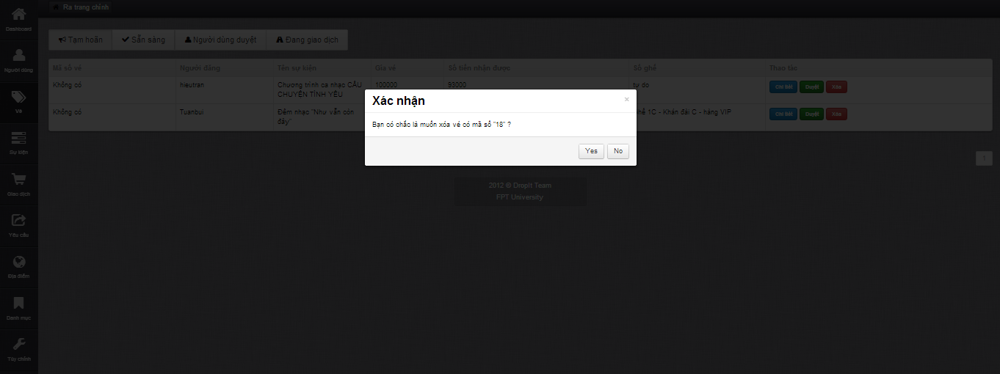

**Figure 6.2.1.2.2 Delete ticket confirm message box**

* Click “Yes” button to confirm delete ticket, finish delete

### Apprive\Disapprove Ticket

* When admin are on “Chưa duyệt” tab (5-6.2.1.2) ,click on “Duyệt” button to approve a ticket
* When admin are on “Đã duyệt” tab (6-6.2.1.2) ,click on “Bỏ duyệt” button to disapprove a ticket
* Message approve/disapprove successful displays on top

### Manage Event

* Click on “Sự kiện” tab (1-6.2.1.3) to enter Manage Event page

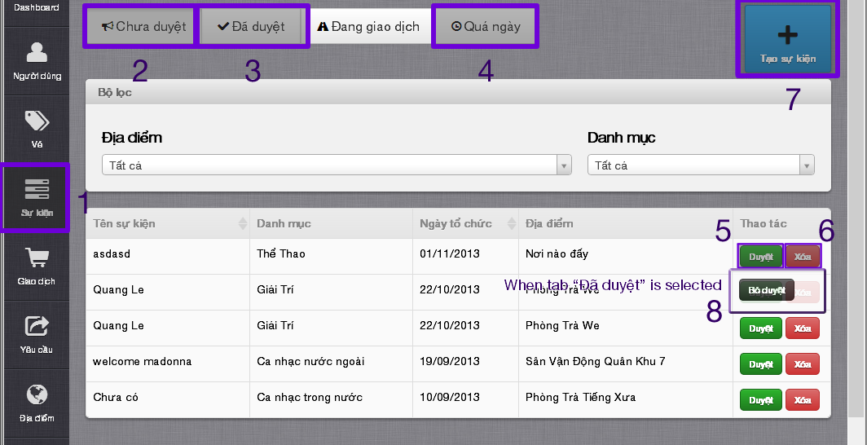

**Figure 6.2.1.3 Manage event UI**

### Create Event

* Click on “Tạo sự kiện” button (7-6.2.1.3) to display Create Event page

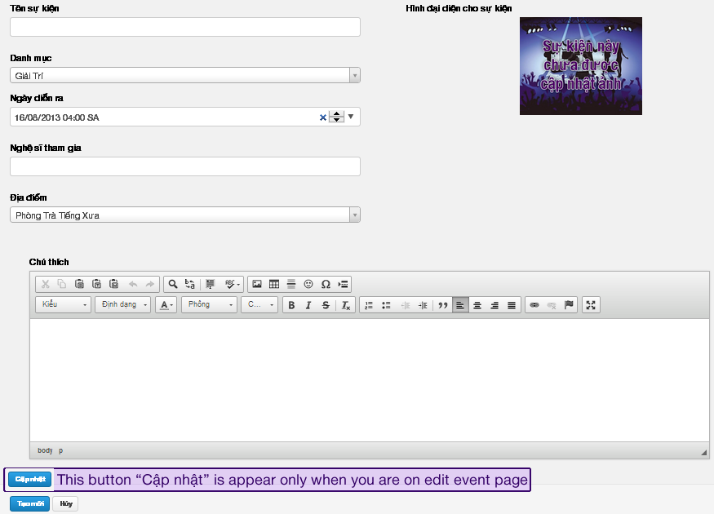

**Figure 6.2.1.3.1 Create\Edit event UI**

* Fill in all mandatory field
* Click on “Tạo mới” button
* After creating completed, navigate back to Manage Event page

### Update Event

* Click on an event to display Update Event page (Figure 6.2.1.3.1)
* Fill in need to update field
* Click on “Cập nhật” button
* After updating complete, navigate back to Manage Event page

### Delete Event

* Choose an event in “Bỏ duyệt” or “Quá ngày” tab and click “Xóa” button (6-6.2.1.3)
* Click on “Yes” button to confirm delete event, finish delete event

### Approve\Disapprove Event

* When admin on “Chưa duyêt” tab (2-6.2.1.3) and click “Duyệt” button to approve event (5-6.2.1.3)
* When admin on “Đã duyêt” tab (3-6.2.1.3) and click “Bỏ duyệt” button to disapprove event (8-6.2.1.3)
* Message approve/disapprove event success displays on top

### Manage Venue

* Click “Địa điểm” tab to enter Manage Venue page

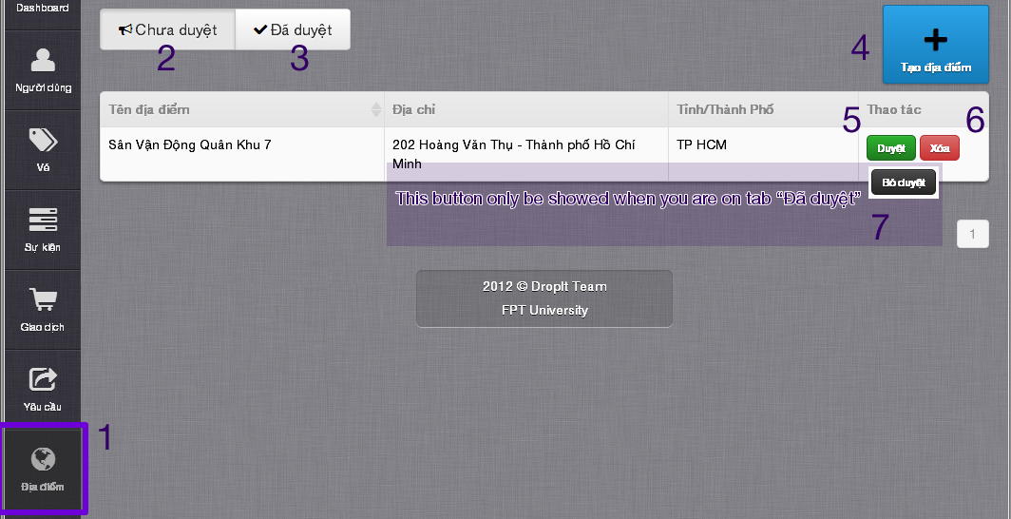

**Figure 6.2.1.4 Manage Venue UI**

### Create Venue

* Click on “Tạo địa điểm” button (4-6.2.1.4) to display Create Venue page

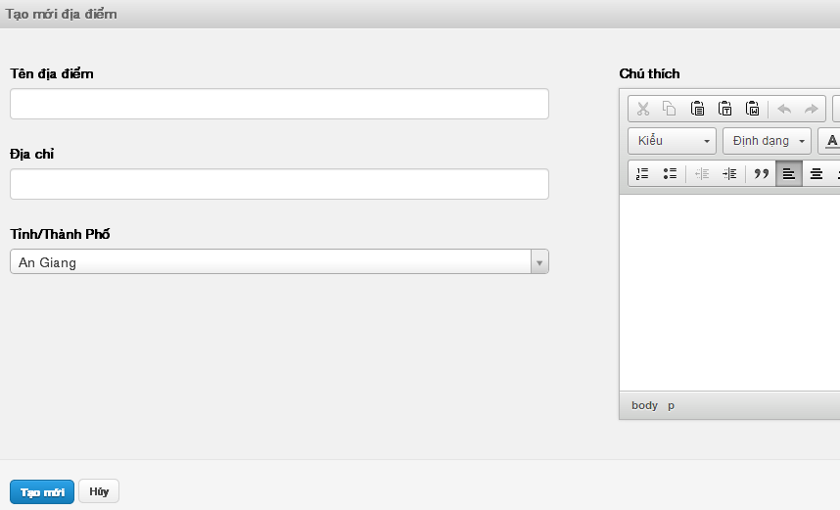

**Figure 6.2.1.4.1 Create\Update Venue UI**

* Fill in all mandatory field
* Click on “Tạo mới” button
* After creating completed, navigate back to Manage Venue page

### Update Venue

* Click on a venue to navigate to display Update Venue page (Figure 6.2.1.4.1)
* Fill in all need-to-update mandatory field
* Click on “Cập nhật” button
* After updating completed, navigate back to Manage Venue page

### Approve\Disapprove Venue

* Click on “Duyệt” button (5-6.2.1.4) in tab “Chưa duyệt” to approve a venue
* Message approve venue successful displays on top
* Click on “Bỏ duyệt” button (7-6.2.1.4) in tab “Đã duyệt” to disapprove a venue
* Message disapprove venue successful displays on top

### Manage Category

* Click on “Danh mục” tab to enter Manage Category page

### Create Category

* Click on “Tạo danh mục” to display Create Category page
* Fill in all mandatory field
* Click on “Tạo mới” button
* After creating completed, navigate back to Manage Category page

### Update Category

* Click on a category to display Update Category page
* Fill in all need-to-update mandatory field
* Click on “Cập nhật” button
* After updating completed, navigate back to Manage Category page

### Show/Hide Category

* Click on “Không hiện” tab to display list of hidden categories
* Choose a category and click “Hiện” to show hidden category
* Click on “Không hiện” tab to display list of show categories
* Choose a category and click “Ẩn” to hide category

### Manage Request

* Click on “ Yêu cầu” tab to enter Manage Request page
* Display list of all open requests on Manage Request page
* Choose a request and click on “Đóng” button
* Click on “Yes” button on confirm message to confirm close request
* Message close request successful displays on top

### Manage Transaction

* Click on “Giao dịch” tab to enter Manage Transaction page

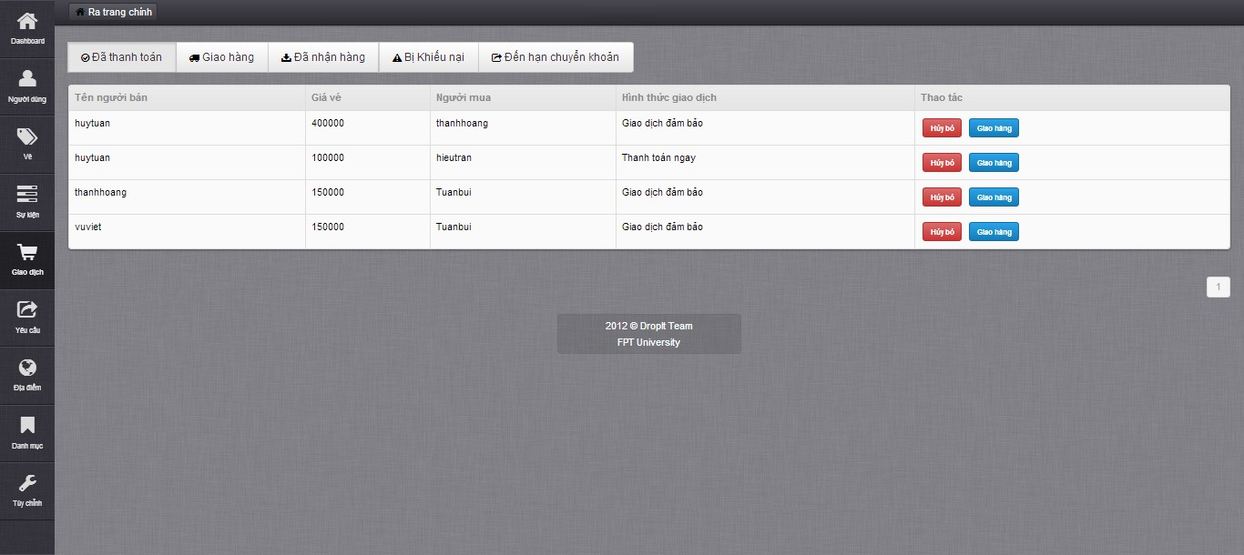

### Update Transaction

* Choose a transaction on “Đã thanh toán” tab and click “Hủy bỏ” button to cancel transaction

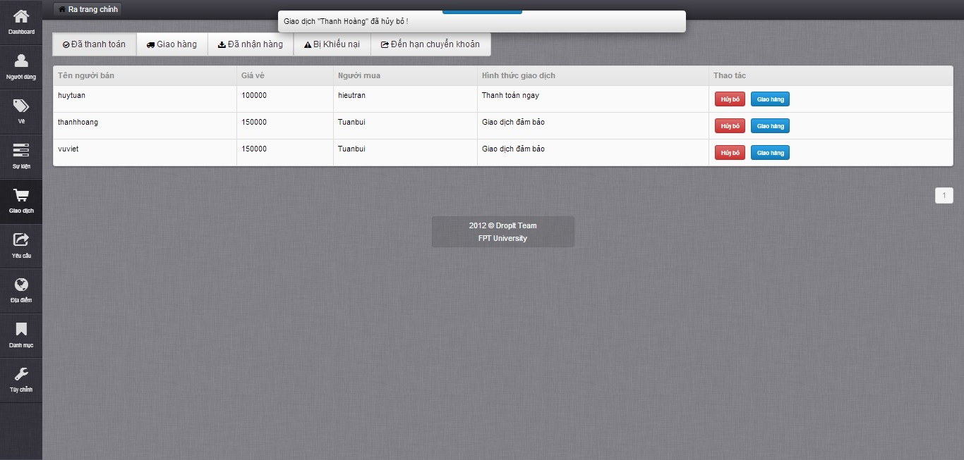

* Choose a transaction on “Đã thanh toán” tab and click “Giao hàng” button to change transaction from paid to delivered

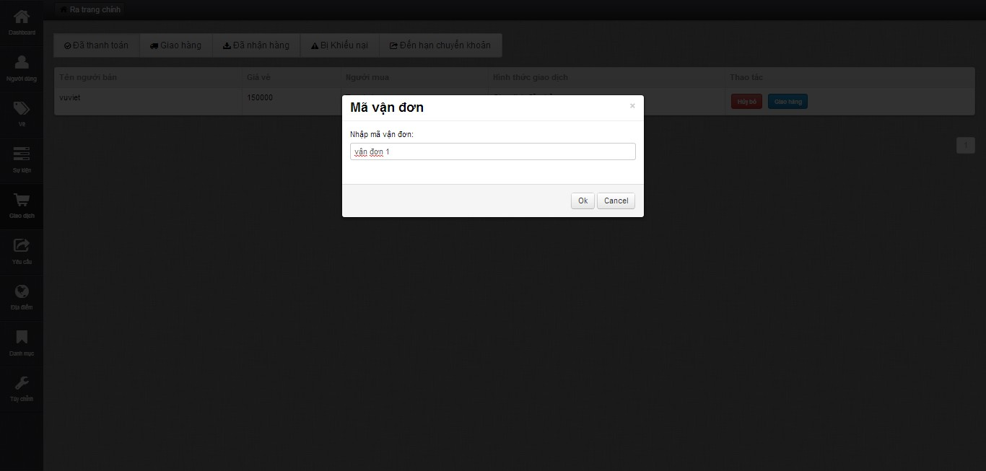

* Fill in “Mã vận đơn” and click “Ok” button to finish change transaction status

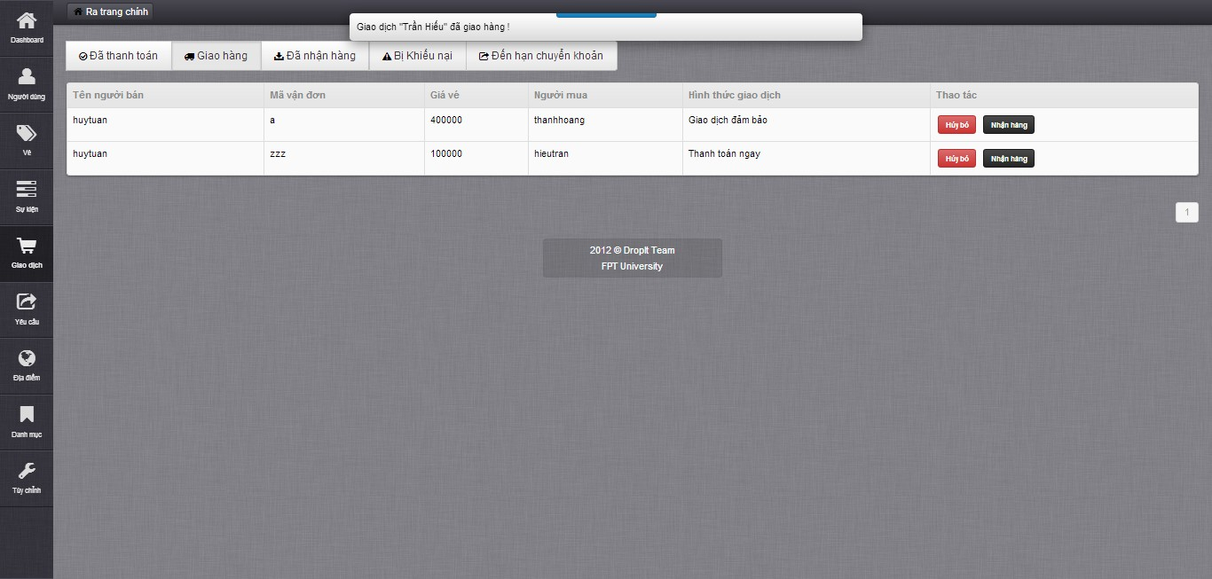

* Click “Hủy bỏ”button in “Giao hang” tab to cancel transaction if transaction got problem
* Click “Nhận hàng” in “Giao hàng” tab to change transaction status to received

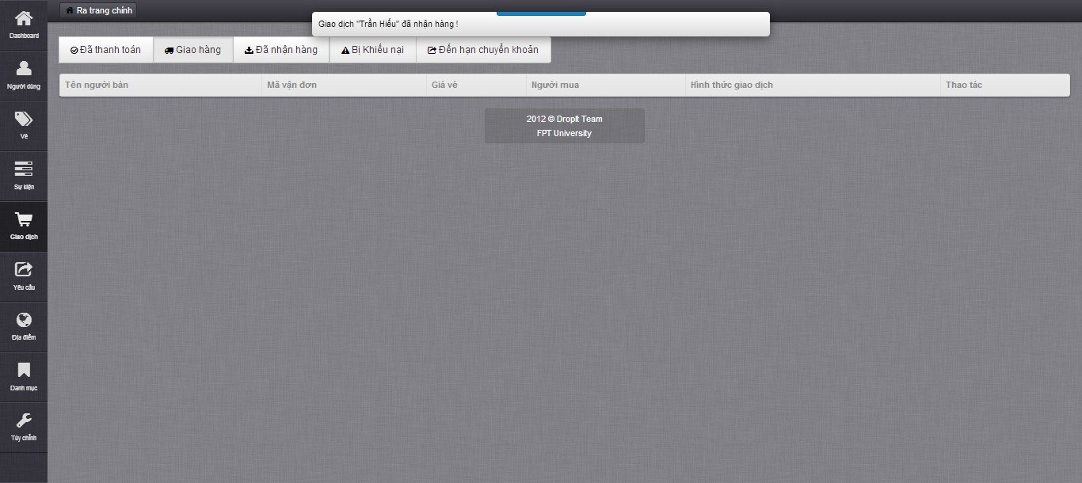

* Click on “Vé vi phạm” button in “Bị khiếu nai” to change transaction status to cancel if ticket got problem
* Click on “Vé vi phạm” button in “Bị khiếu nai” to change transaction status if ticket and transaction got no problem

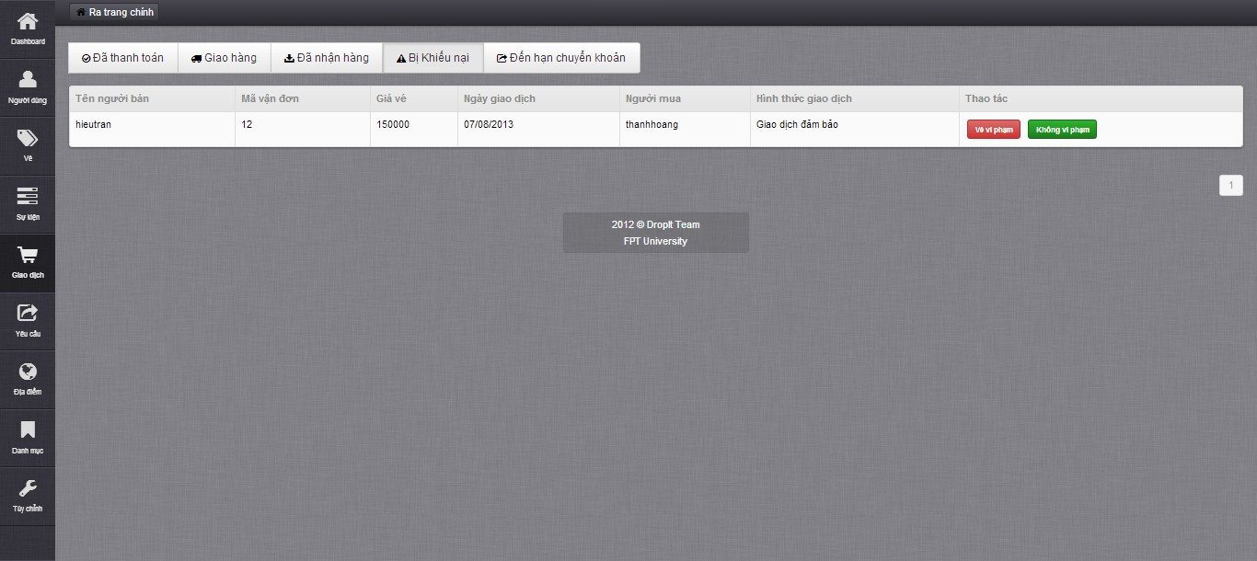

* Click on “Hoàn thành” button on “Đến hạn chuyển khoản” tab to confirm transaction done

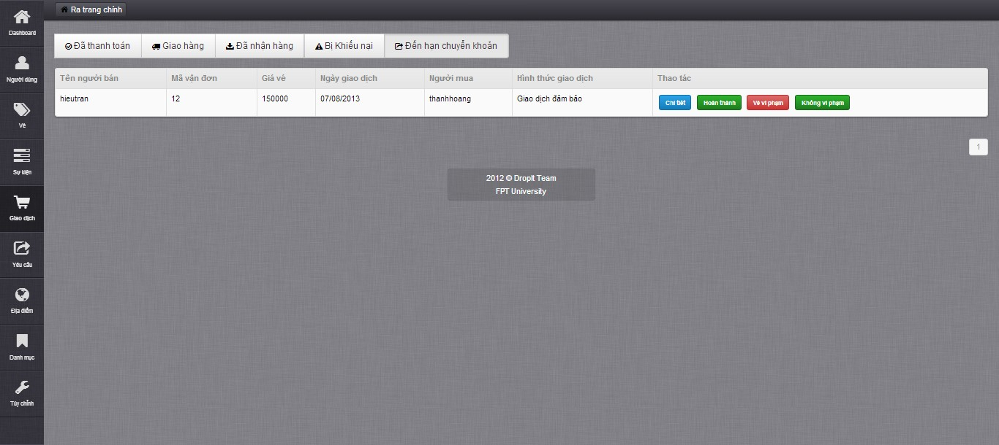

## **User’s Guide**

### View Website basically

* Home page interface

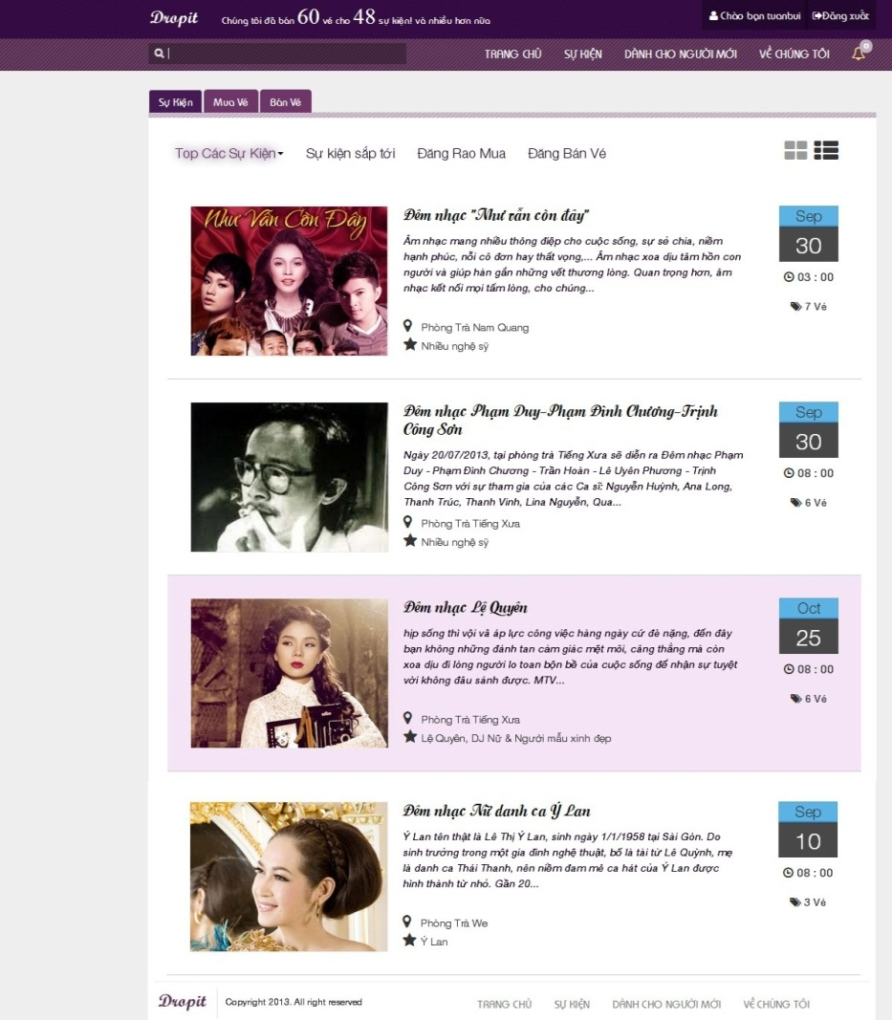

* Click on an event to view event details and information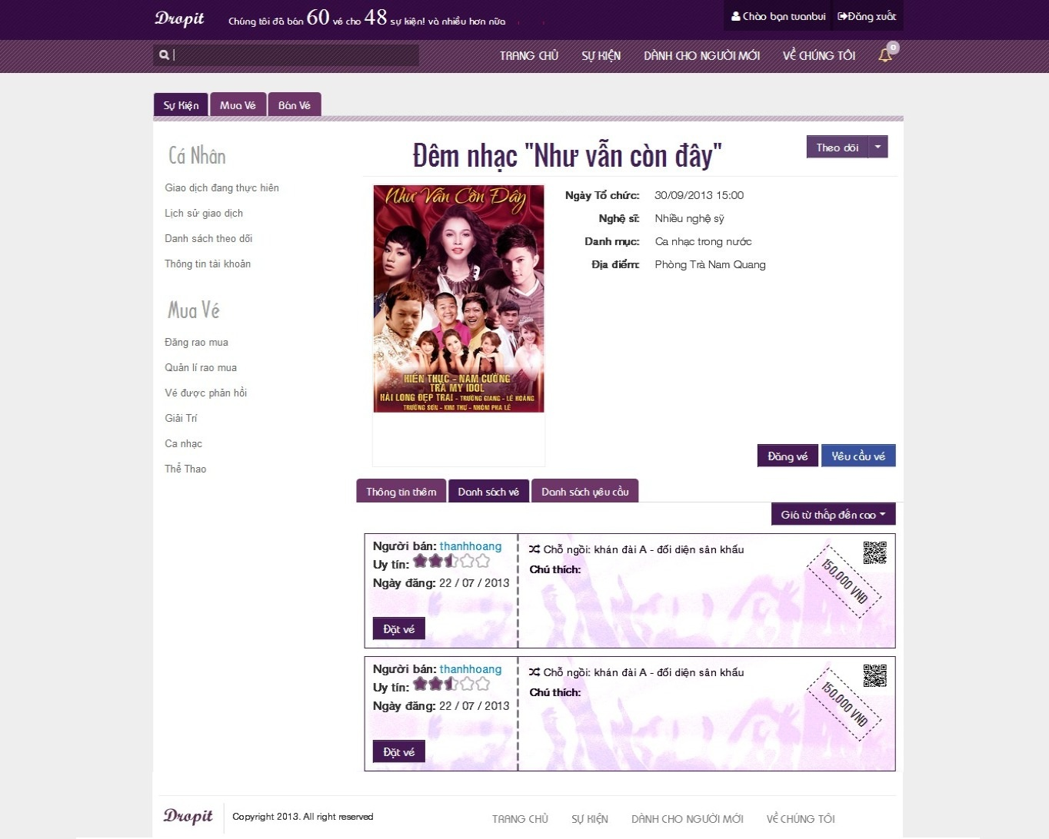

### Register

* Click on “Đăng kí” button on top right to enter Register page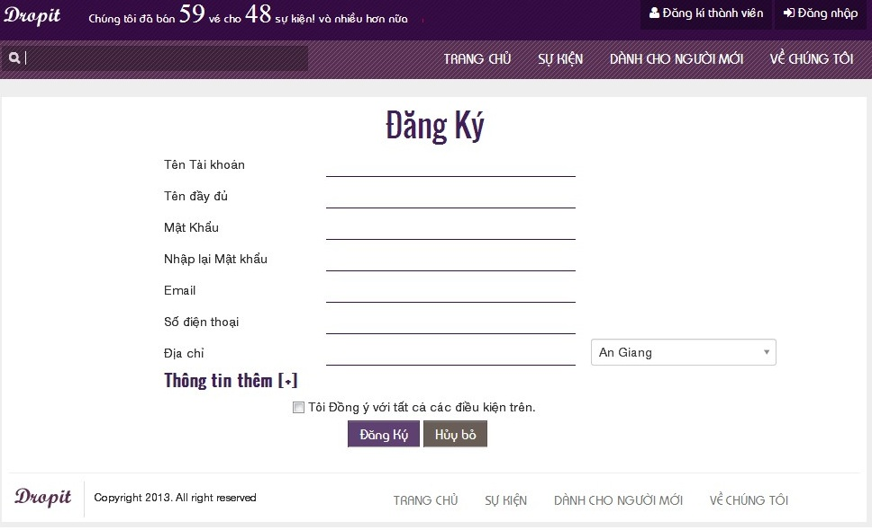
* Fill in all mandatory fields and checkbox
* Click on “Đăng ký” button to finish register

### Login

* Click on “Đăng nhập” button to login to system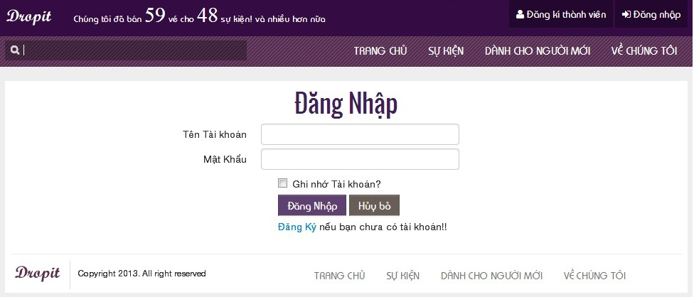
* Fill in all mandatory fields
* Click “Đăng nhập” button to login to system

### Buy Ticket

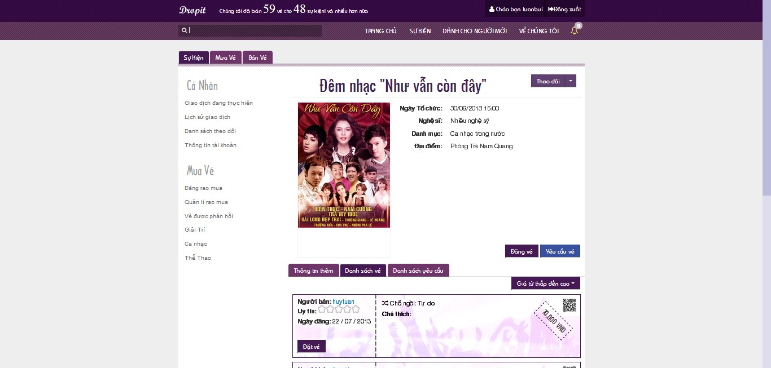

* Click on “Đặt vé” button in event page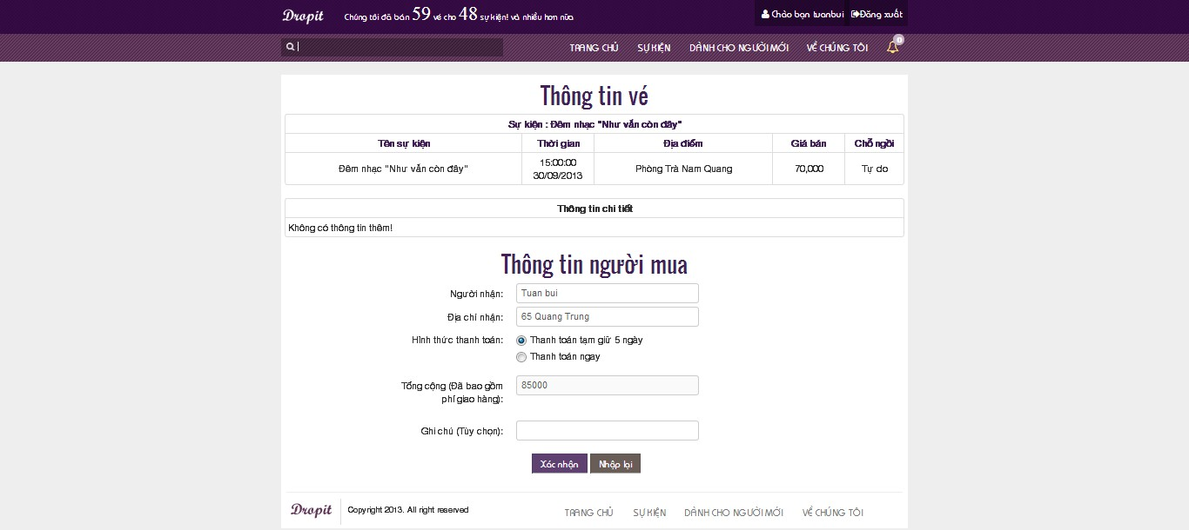
* Click on “Xác nhận” button to change to PayPal page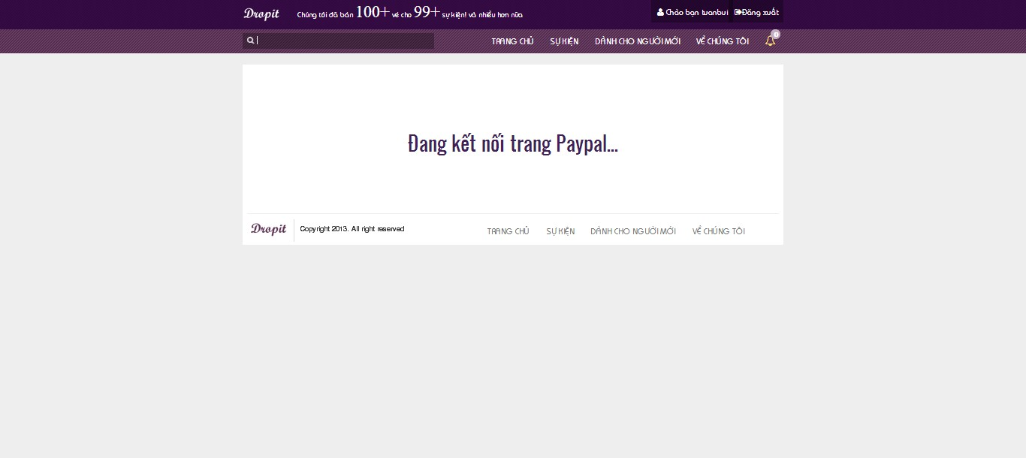
* PayPal interface

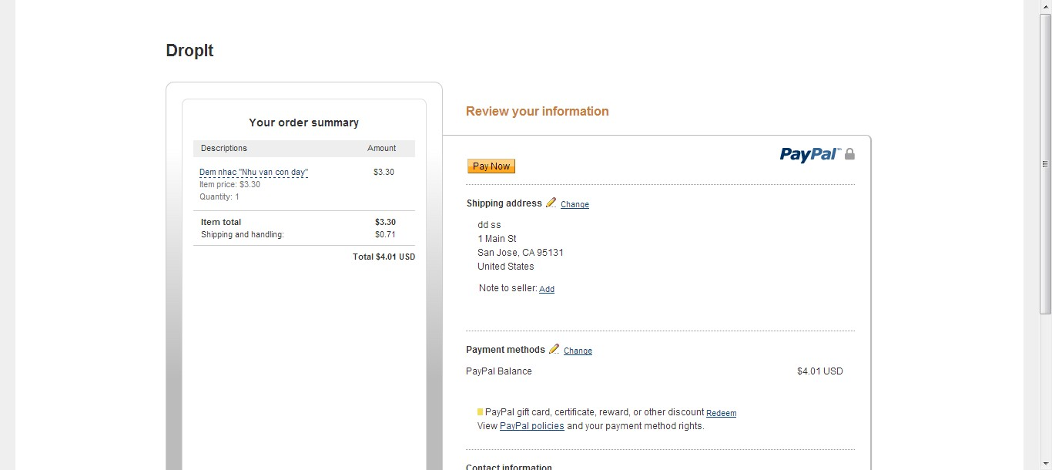

* Return Drop It system and show success page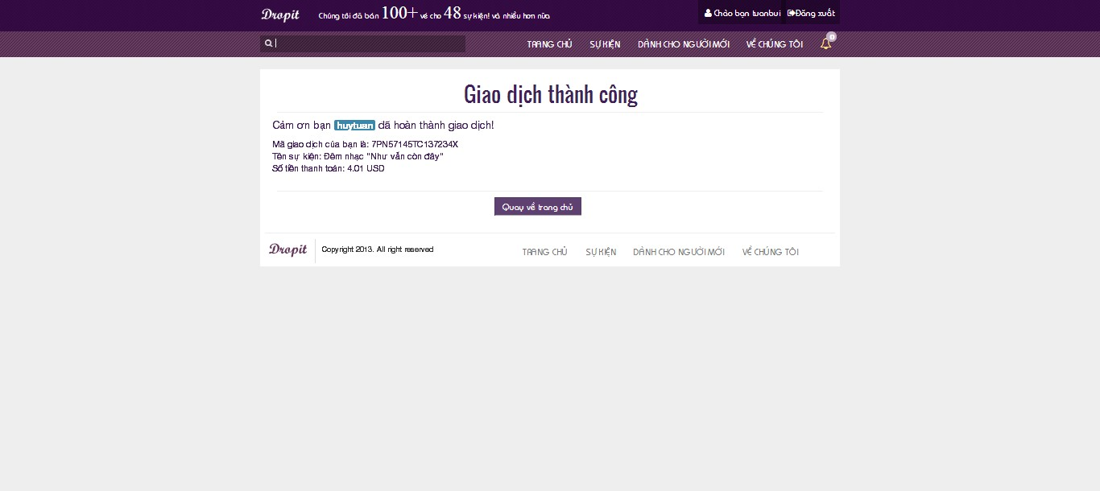

### Post Ticket

* Click on “Đăng bán vé” button in homepage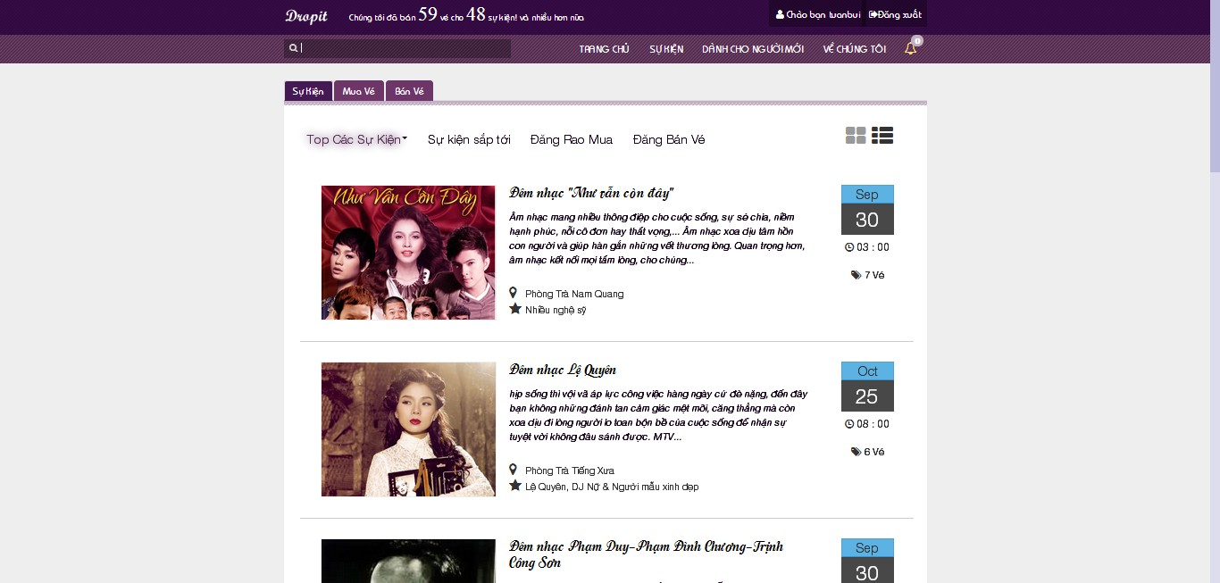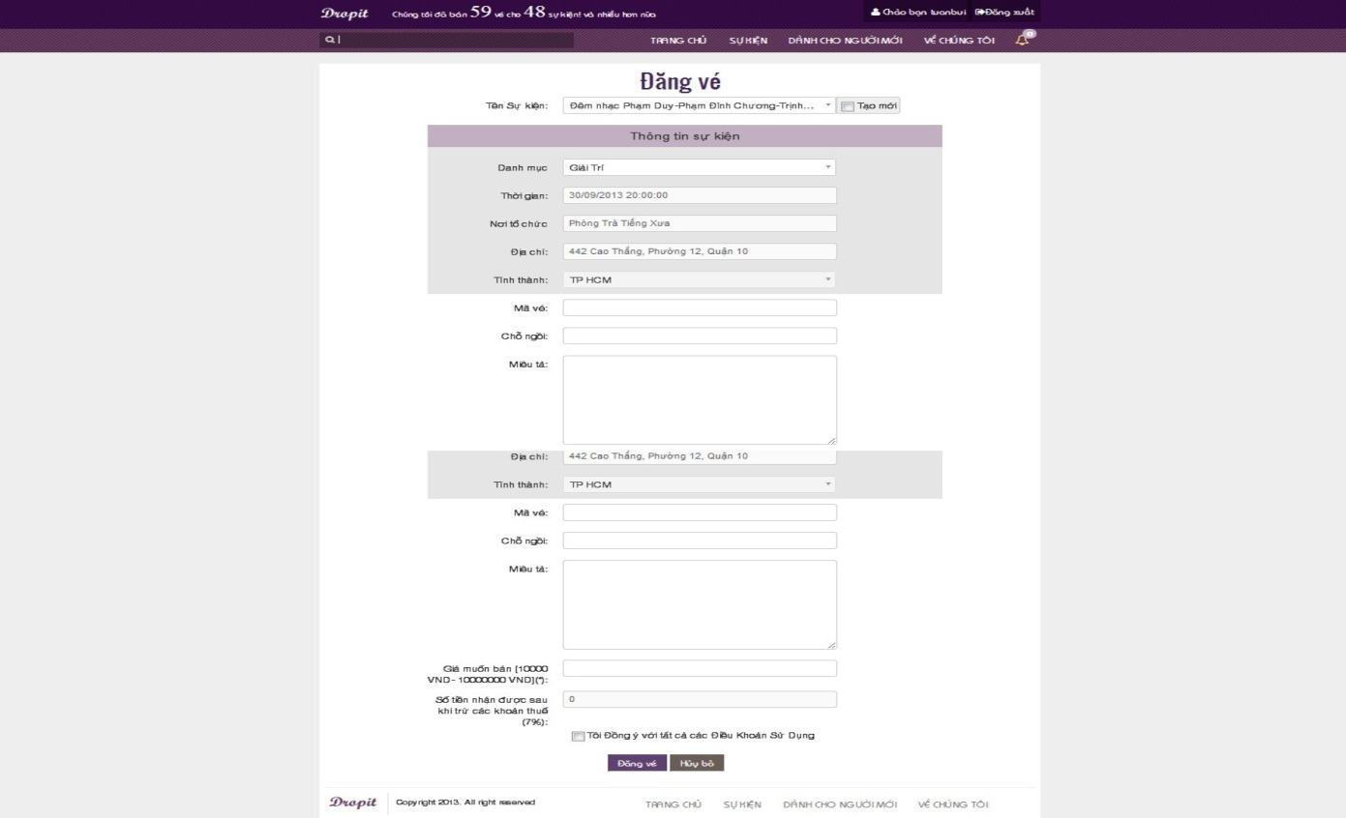
* Fill in all mandatory field
* Click “Đăng vé” button to finish post ticket

### Post Ticket with new event

* When there is no event which match with your desired event you can check on “Tạo mới” checkbox next to the “Tên sự kiện” to input your new event.
* In this case, you fill your information like normal but when you finish your post system will show you some suggestion that can match your event which you think is missing.

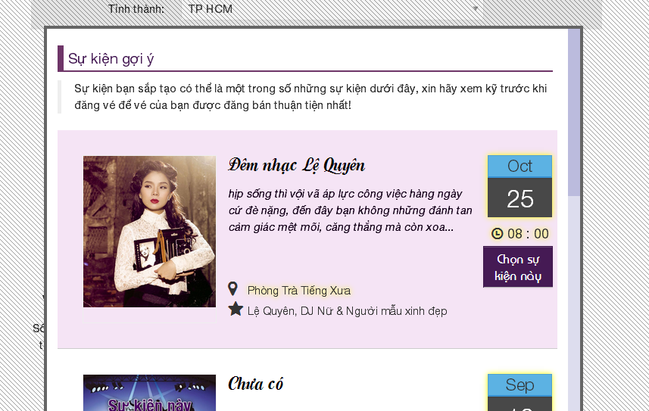

* You can choose system’s suggestion or continue with your own new.

### Update Posted Ticket

* Click on “Quản lý vé” in homepage, then click on “Được phép” tab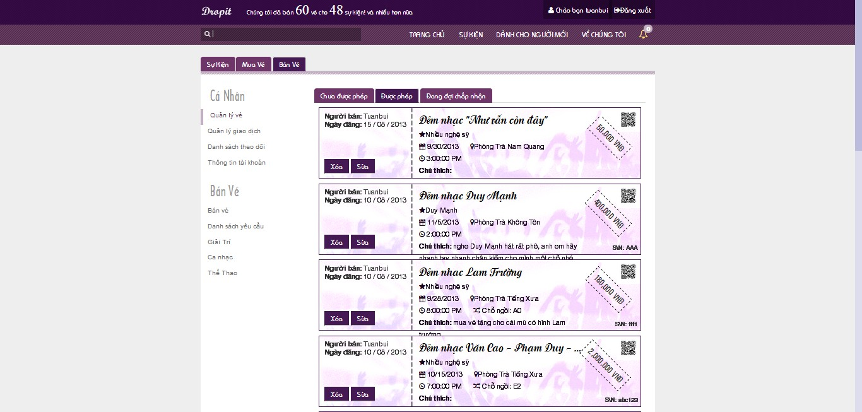
* Choose a ticket and click on “Sửa” button to display Update Ticket page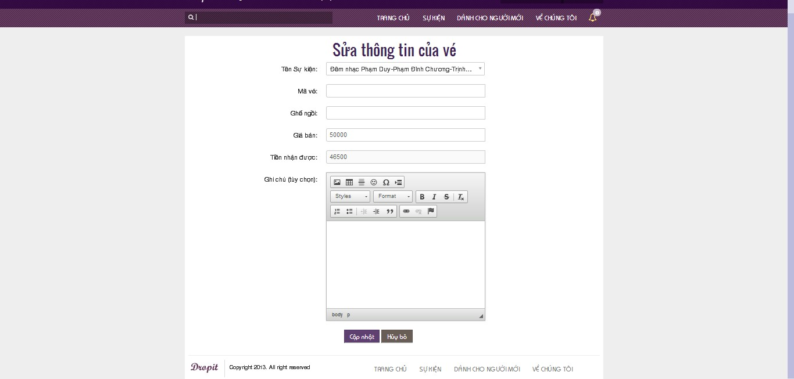
* Fill in all need-to-update mandatory fields
* Click “Cập nhật” button to finish updating
* After updating complete, navigate back to Sell Ticket page

### Delete Posted Ticket

* Choose a ticket and click on “Xóa” button to delete Ticket page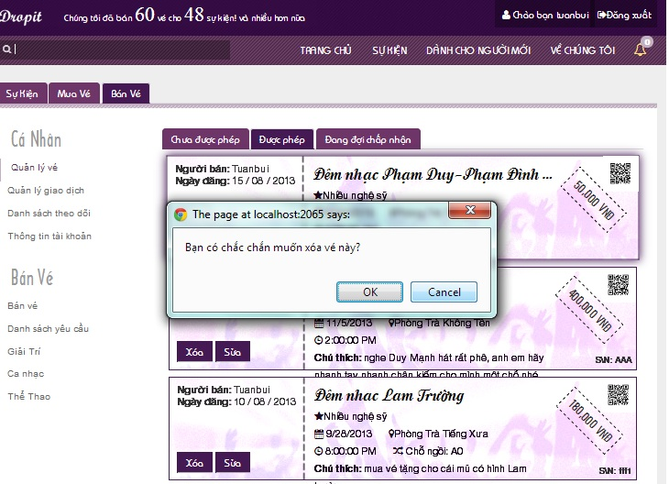
* Click “OK” button to finish delete a ticket

### Request Ticket

* Click on “Đăng rao mua” button in homepage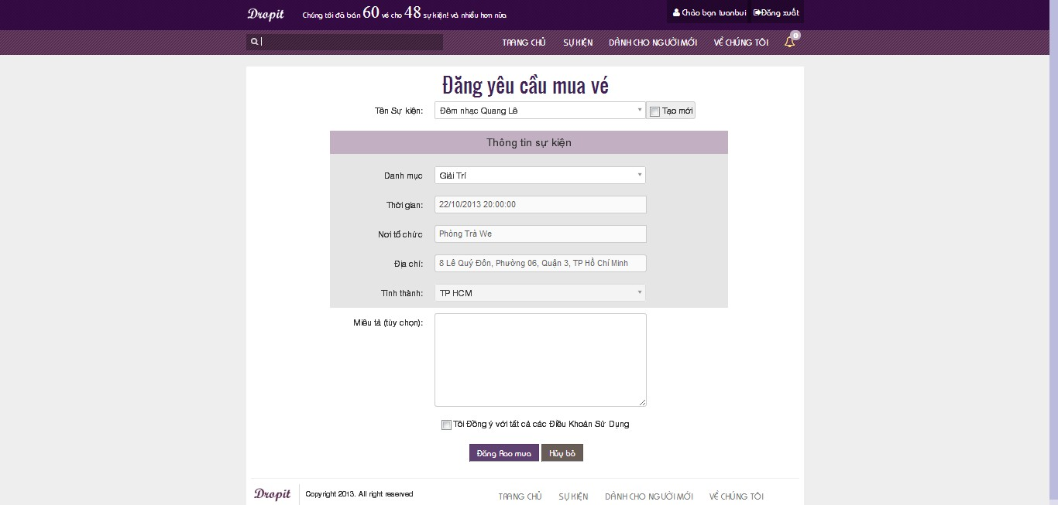
* Fill in all mandatory fields
* Click “Đăng rao mua” button to finish request ticket
* When you request ticket and create your own new event, DropIt will suggest like you post ticket. (6.2.2.5)

### Respond Ticket

* Click on “Bán vé” tab, then click on “Danh sách yêu cầu” link on left side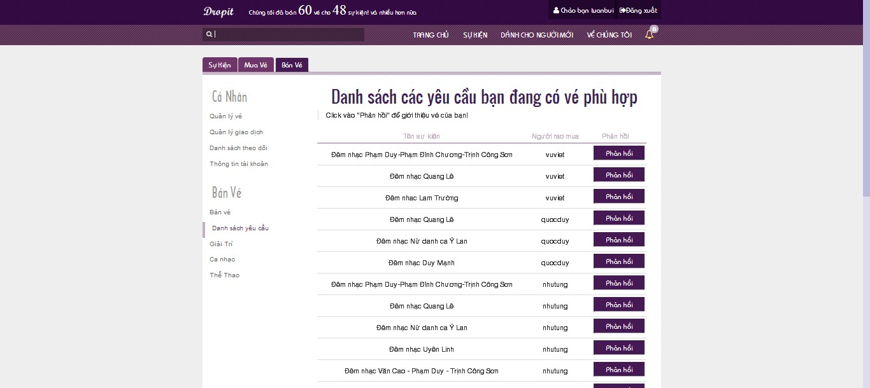
* Choose a request and click on “Phản hồi” to response ticket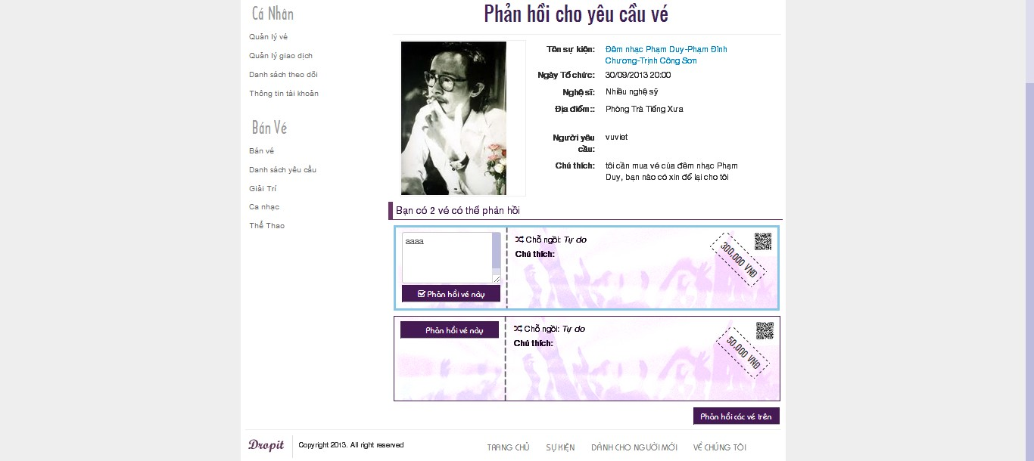
* Choose request that user has ticket for responding and click “Phản hồi các vé trên” to respond ticket

### Close Ticket Request

* Click “Mua vé” tab, then click on “Quản lí rao mua” link to view list of requests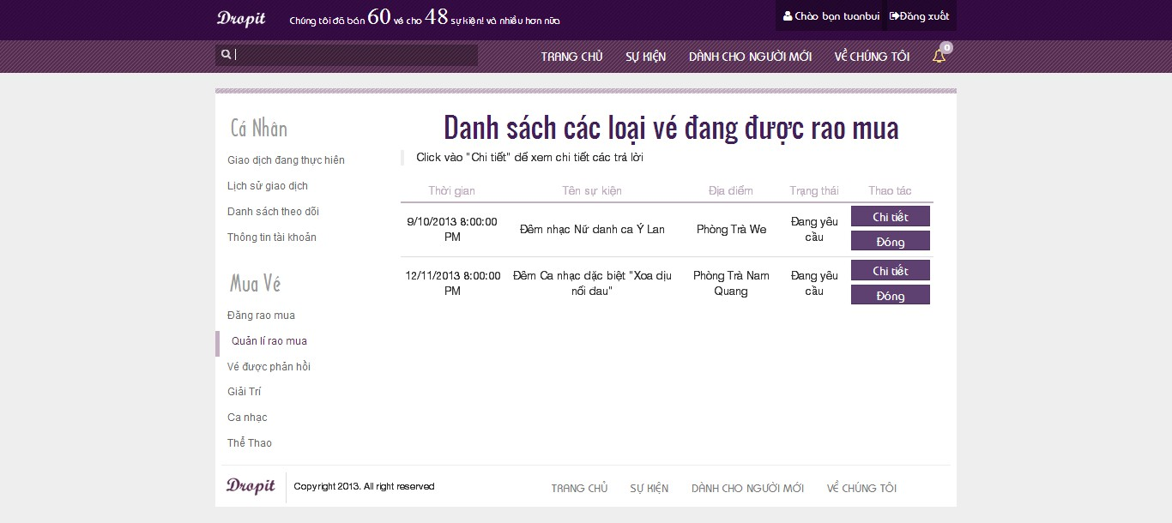
* Choose a request and click “Đóng” button to close request

### View Buy History

* Click “Mua vé” tab, then click on “Giao dịch đang thực hiện” link to view list of transactions are in progress

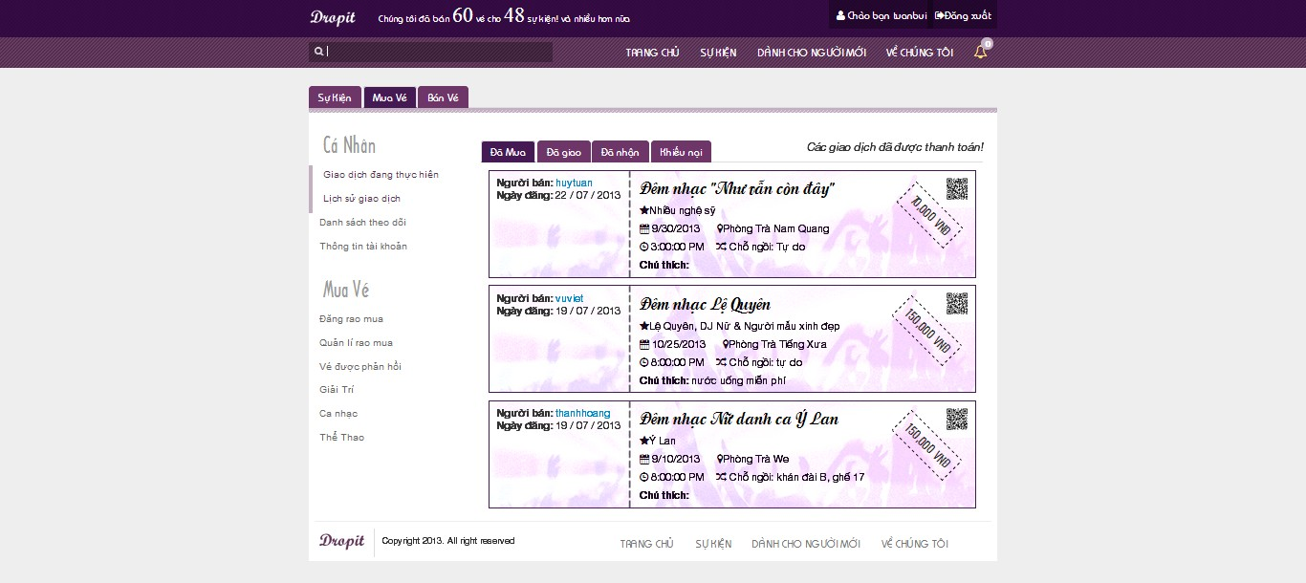

### View Sell History

* Click “Bán vé” tab, then click on “Quản lý giao dịch” link to view list of ticket transactions

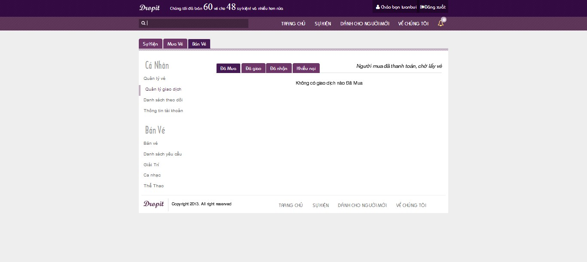

* Click “Đã mua” tab, “Đã giao” tab, “Đã nhận” tab or “khiếu nại” tab to view sell history

### Follow/Unfollow Buy Event

* Click on an event to view event details

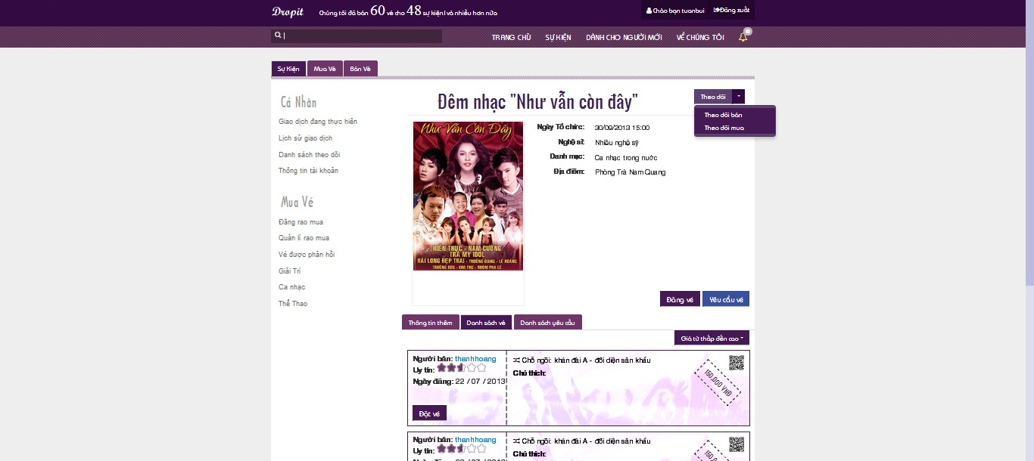

* Click on “Phản hồi” drop down list to choose “Theo dõi mua” or “Theo dõi bán” to follow buy or follow sell event
* Click on “Phản hồi” button to follow buy and sell event

### View Follow List

* Click on “Danh sách theo dõi” link in “Cá nhân” field to view list follow events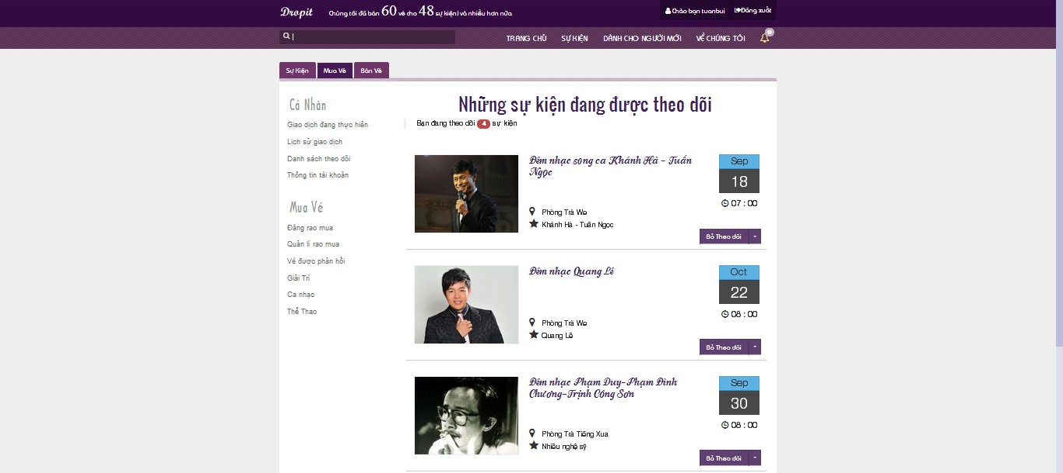

### View Notification List

* Click on alarm label on top right to view notification list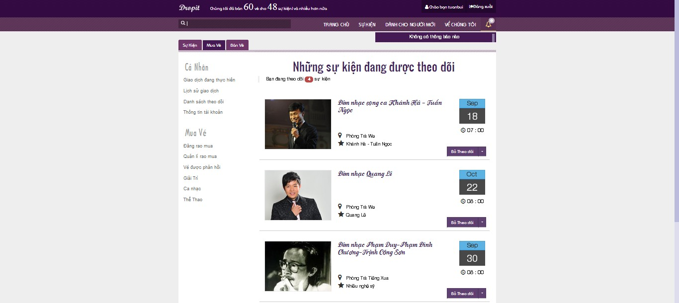

### Change Password

* Click “Bán vé” tab or “Mua vé” tab, then click on “Thông tin tài khoản” link to view personal information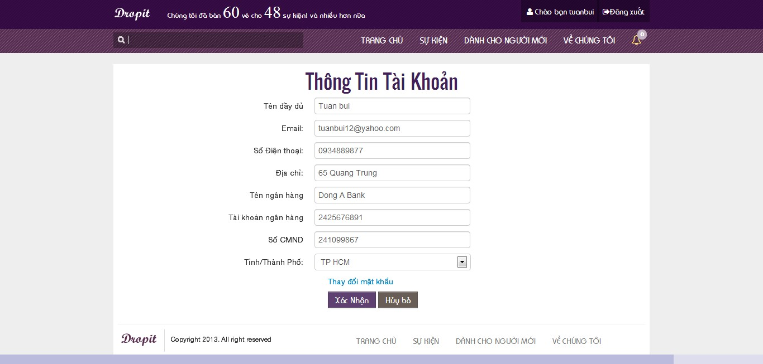
* Click “Thay đổi mật khẩu” link to display Change Password page
* Or click on username on top right to display Change Password page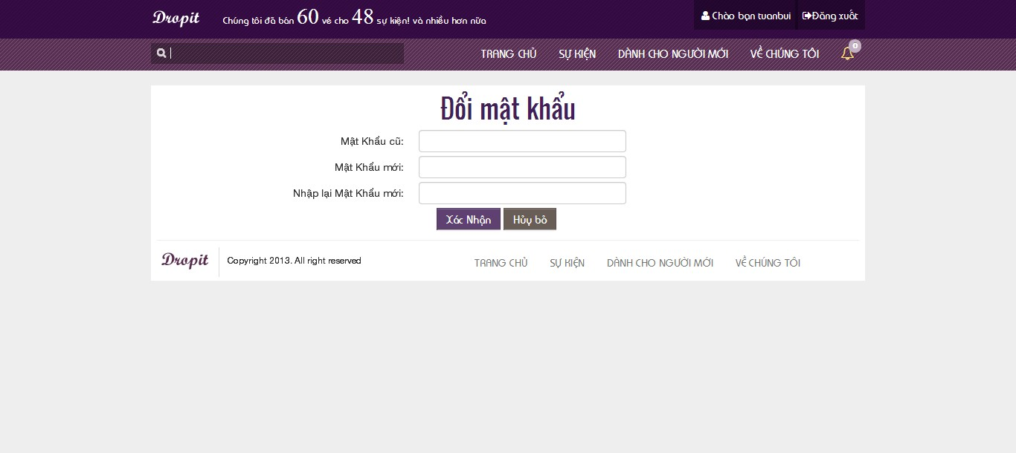
* Fill in all mandatory fields
* Click on “Xác nhận” button to finish change password

### Change Personal Information

* Click “Bán vé” tab or “Mua vé” tab, then click on “Thông tin tài khoản” link to view personal information
* Fill in all need-to-update fields
* Click on “Xác nhận” button to save changed information

### Search Event

* Input information want to search into search box, system will suggest result if there are matching results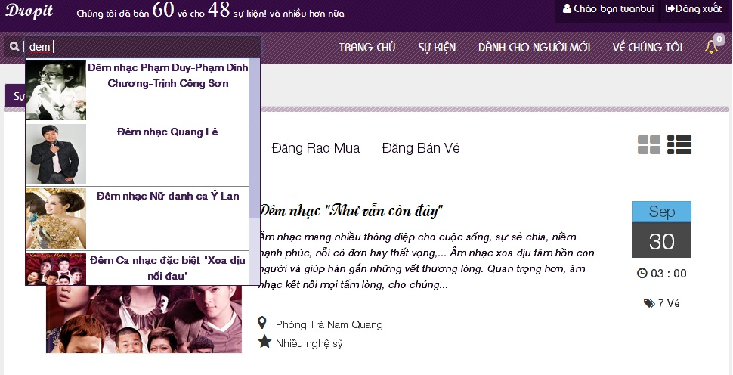
* Click on suggest result to view event
* Or continue input string want to search and click on search label or press enter key to search
* Display Search Result page

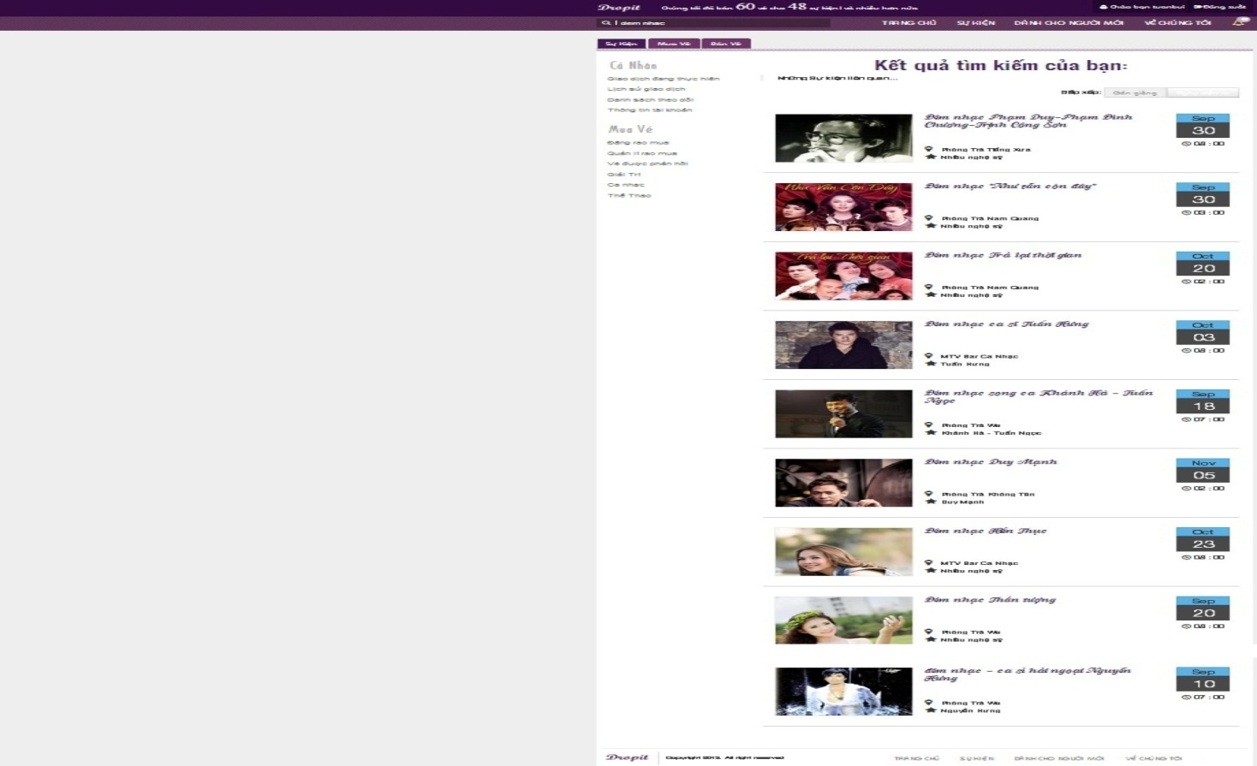

### Logout

* Click on “Đăng xuất” button at top right to logout of the system